Nombre: Período: Fecha: 6A vocab
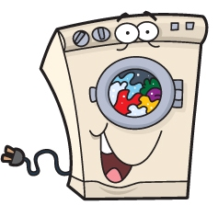
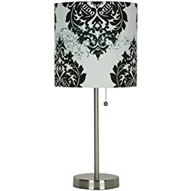

En mi Dormitorio
Español 1

To talk about things in a bedroom black
rug red
closet Pink
bed green
dresser To Describe something
curtains pretty
painting ugly
alarm clock large
bedroom important
mirror same
shelf; bookshelf small
lamp own
night table To indicate location
wall to the right (of)
to the left (of)
TO talk about electronic equipment
Compact disc To compare and contrast
Sound (stereo) system better than
DVD player the best
Television set less, fewer…than
Video worse than
TO talk about colors the worst
Colors Other useful words
Yellow thing
Orange in my opinion, for me
Blue in your opinion, for you
White possession
gray
brown
purple
Extra vocab: pg 473
Balcony: el balcón, los balcones microwave oven: el microondas
Stove: la estufa furniture: los muebles
Garden: el jardín, los jardines patio: patio
Laundry room: el lavadero refrigerator: refrigerador
Washing machine: la lavadora clothes dryer: la secadora
Armchair: el sillón; los sillones sofa: el sofá
Dressing table: el tocador light blue: azul claro
Navy blue: azul marino dark blue: azul oscuro

Gramática— BOOT VERBS Dormir, Poder, volver,
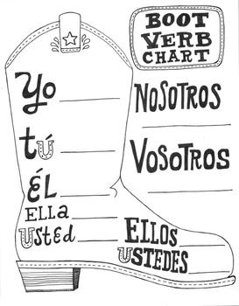

Práctica Traduce al español después de leer la Gramática de arriba y vocabulario.

- Sra. DL likes to sleep a lot. ___________________________________________________________
- They sleep late on the weekends. ___________________________________________________________
- I can study more. ___________________________________________________________
- You(informal) can do the homework. ___________________________________________________________
- He returns home at 5:30pm. ___________________________________________________________
- The bed is big. ___________________________________________________________
- I have my own sounds system. _____________________________________________________
- The dresser is small and next to the wall. _________________________________________________

